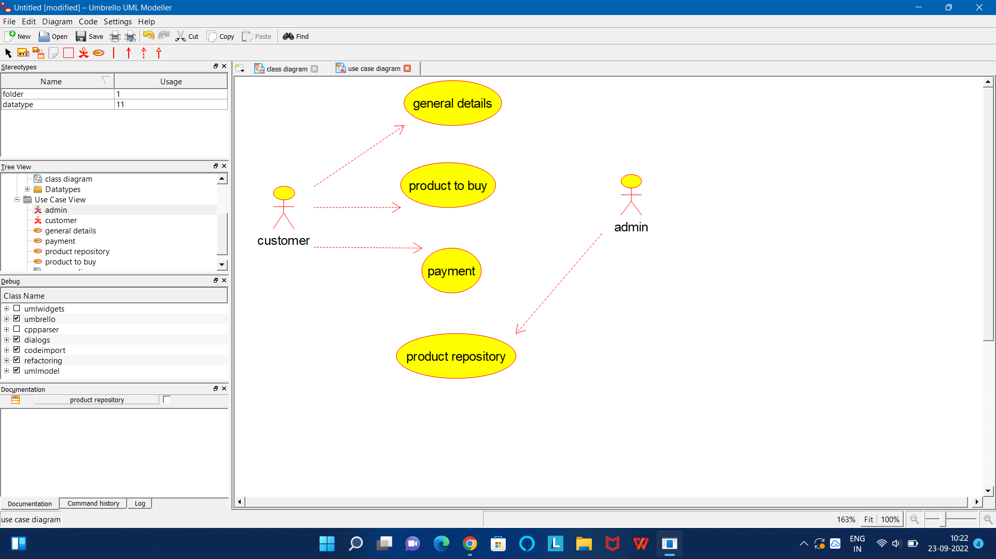

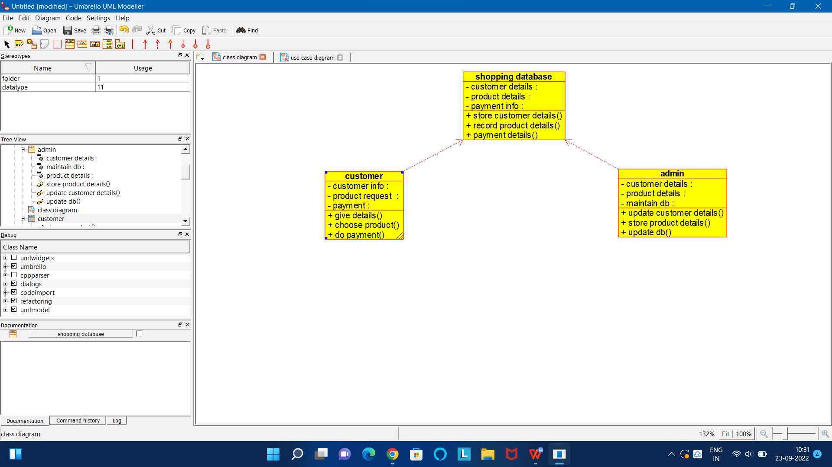

CODE FOR ADMIN:

/**

* Class admin

*/

public class admin {

//

// Fields

//

private void customer_details;

private void product_details;

private void maintain_db;

//

// Constructors

//

public admin () { };

//

// Methods

//

//

// Accessor methods

//

/**

* Set the value of customer_details

* @param newVar the new value of customer_details

*/

private void setCustomer_details (void newVar) {

customer_details = newVar;

}

/**

* Get the value of customer_details

* @return the value of customer_details

*/

private void getCustomer_details () {

return customer_details;

}

/**

* Set the value of product_details

* @param newVar the new value of product_details

*/

private void setProduct_details (void newVar) {

product_details = newVar;

}

/**

* Get the value of product_details

* @return the value of product_details

*/

private void getProduct_details () {

return product_details;

}

/**

* Set the value of maintain_db

* @param newVar the new value of maintain_db

*/

private void setMaintain_db (void newVar) {

maintain_db = newVar;

}

/**

* Get the value of maintain_db

* @return the value of maintain_db

*/

private void getMaintain_db () {

return maintain_db;

}

//

// Other methods

//

/**

*/

public void update_customer_details()

{

}

/**

*/

public void store_product_details()

{

}

/**

*/

public void update_db()

{

}

}

CODE FOR CUSTOMER:

/**

* Class customer

*/

public class customer {

//

// Fields

//

private void customer_details;

private void customer_address;

private void payment;

//

// Constructors

//

public customer () { };

//

// Methods

//

//

// Accessor methods

//

/**

* Set the value of customer_details

* @param newVar the new value of customer_details

*/

private void setCustomer_details (void newVar) {

customer_details = newVar;

}

/**

* Get the value of customer_details

* @return the value of customer_details

*/

private void getCustomer_details () {

return customer_details;

}

/**

* Set the value of customer_address

* @param newVar the new value of customer_address

*/

private void setCustomer_address (void newVar) {

customer_address = newVar;

}

/**

* Get the value of customer_address

* @return the value of customer_address

*/

private void getCustomer_address () {

return customer_address;

}

/**

* Set the value of payment

* @param newVar the new value of payment

*/

private void setPayment (void newVar) {

payment = newVar;

}

/**

* Get the value of payment

* @return the value of payment

*/

private void getPayment () {

return payment;

}

//

// Other methods

//

/**

*/

public void place_order()

{

}

/**

*/

public void track_order()

{

}

}

CODE FOR SHOPPING DATABASE:

/**

* Class shopping_database

*/

public class shopping_database {

//

// Fields

//

private void customer_details;

private void product_details;

private void payment_info;

//

// Constructors

//

public shopping_database () { };

//

// Methods

//

//

// Accessor methods

//

/**

* Set the value of customer_details

* @param newVar the new value of customer_details

*/

private void setCustomer_details (void newVar) {

customer_details = newVar;

}

/**

* Get the value of customer_details

* @return the value of customer_details

*/

private void getCustomer_details () {

return customer_details;

}

/**

* Set the value of product_details

* @param newVar the new value of product_details

*/

private void setProduct_details (void newVar) {

product_details = newVar;

}

/**

* Get the value of product_details

* @return the value of product_details

*/

private void getProduct_details () {

return product_details;

}

/**

* Set the value of payment_info

* @param newVar the new value of payment_info

*/

private void setPayment_info (void newVar) {

payment_info = newVar;

}

/**

* Get the value of payment_info

* @return the value of payment_info

*/

private void getPayment_info () {

return payment_info;

}

//

// Other methods

//

/**

*/

public void store_customer_details()

{

}

/**

*/

public void record_product_details()

{

}

/**

*/

public void payment_details()

{

}

}